Git Branching Strategies
Created by: Dimitar Malamski
Malamski,Dimitar D.S.
mitemalamata@gmail.com
Additional info:
Done for Semester 2, software engineering at Fontys ICT, Eindhoven, The Netherlands
Date: 12.06.2025

Table of Contents
Abstract 2
How I Used Git in My Projects 2
Git Branching Strategies 2
Git Flow 2
GitHub Flow 3
GitLab Flow 4
Trunk-based Development 5
Conclusion 6
References 7

Abstract
Git is a powerful version control system that enables developers to track project progress, collaborate efficiently, and retrieve previous versions when needed. It is widely adopted in both individual and team-based software development. This paper explores several Git branching strategies used in large-scale projects, evaluating their advantages and disadvantages based on software engineering research and practical application.

How I Used Git in My Projects
In my individual project, I primarily worked on a single branch and committed changes regularly after implementing new features. This approach proved effective; when issues arose, it was easy to revert to a previous stable commit.
In contrast, during my group project (consisting of four members), each team member used a separate branch. We implemented new features independently and merged changes into the main branch after group review. While this provided some structure, it also led to merge conflicts and coordination challenges. This experience prompted me to research formal Git branching strategies to better understand best practices.

Git Branching Strategies

Git Flow
Git Flow is a structured workflow introduced by Vincent Driessen (2010). It organizes the codebase into multiple branches - main, develop, feature, release, and hotfix - each with a specific role (Driessen, 2010).
Advantages:
- Clearly separates development, releases, and urgent fixes.
- Supports large teams and projects with structured release cycles.
Disadvantages:
- Overhead is high for smaller or fast-moving projects.
- The model can be complex for developers unfamiliar with strict workflows.

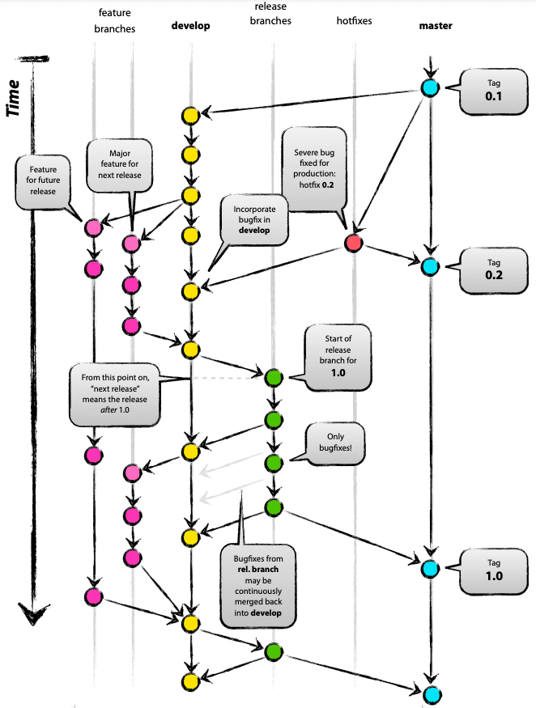

GitHub Flow
GitHub Flow is a simplified model ideal for continuous deployment. Developers create short-lived branches directly from main, commit changes, and open pull requests for peer review before merging (GitHub, n.d.).
Advantages:
- Encourages collaboration and code reviews.
- Supports continuous integration and delivery.
Disadvantages:
- Lacks formal structure for long-term version support or hotfixes.
- In my group project, using separate branches for individuals (instead of features) led to merge issues—an example of poor adherence to this strategy.

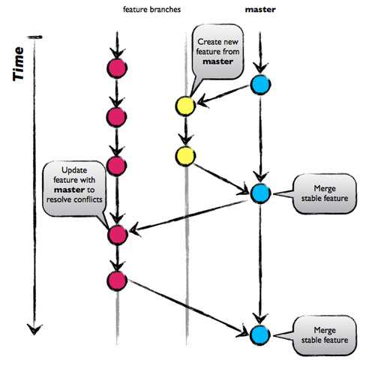

GitLab Flow
GitLab Flow combines the structured branching of Git Flow with GitHub Flow's simplicity and adds environment-aware branches and issue tracking (GitLab Docs, n.d.).
Advantages:
- Encourages issue-driven development.
- Aligns well with CI/CD pipelines and modern DevOps practices.
Disadvantages:
- Can be confusing without team-wide alignment.
- Slightly more complex to implement in smaller teams.

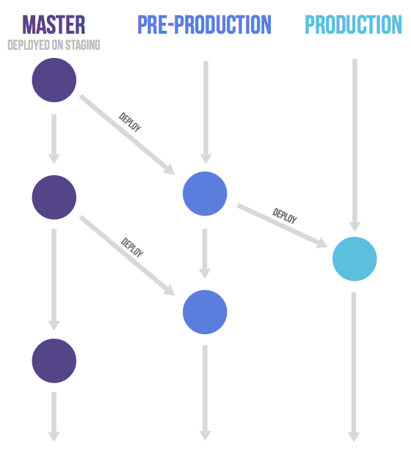

Trunk-based Development
In trunk-based development, developers commit frequently (often daily) to a shared main branch, avoiding long-lived feature branches. Incomplete features are hidden using feature flags (Fowler, 2018).
Advantages:
- Reduces merge conflicts by encouraging continuous integration.
- Enables fast, incremental delivery.
Disadvantages:
- Requires mature development practices and strong testing infrastructure.
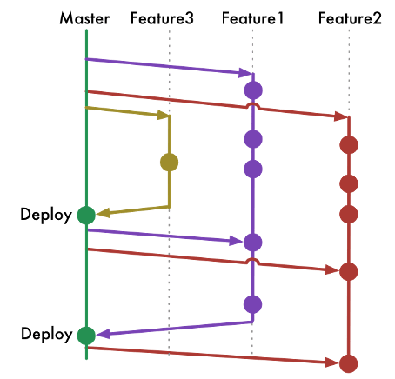
- Risk of introducing bugs if coordination is weak.

Conclusion
This paper explored several Git branching strategies. Each approach offers unique benefits and challenges depending on the team's size, workflow preferences, and project complexity. Through this research, I gained a deeper understanding of how structured a solid Git workflow for any projects, no matter if they are individual ones or group ones. My past use of Git lacked formal strategy, which sometimes led to inefficiencies. Going forward, I plan to apply the most suitable branching model based on the project's scope and team dynamics. This will help improve coordination, reduce merge conflicts, and ensure a cleaner development process. Finally, this will allow me to follow a strict routine, which is essential thing for a solid software developer.

References
Driessen, V. (2010). A successful Git branching model. https://nvie.com/posts/a-successful-git-branching-model/
GitHub. (n.d.). GitHub flow. https://docs.github.com/en/get-started/quickstart/github-flow
GitLab Docs. (n.d.). GitLab flow. https://docs.gitlab.com/ee/topics/gitlab_flow/
Fowler, M. (2018). Trunk-based development. https://martinfowler.com/articles/branching-patterns.html

